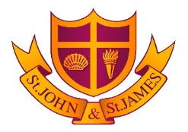

**GIRLS UNIFORM**

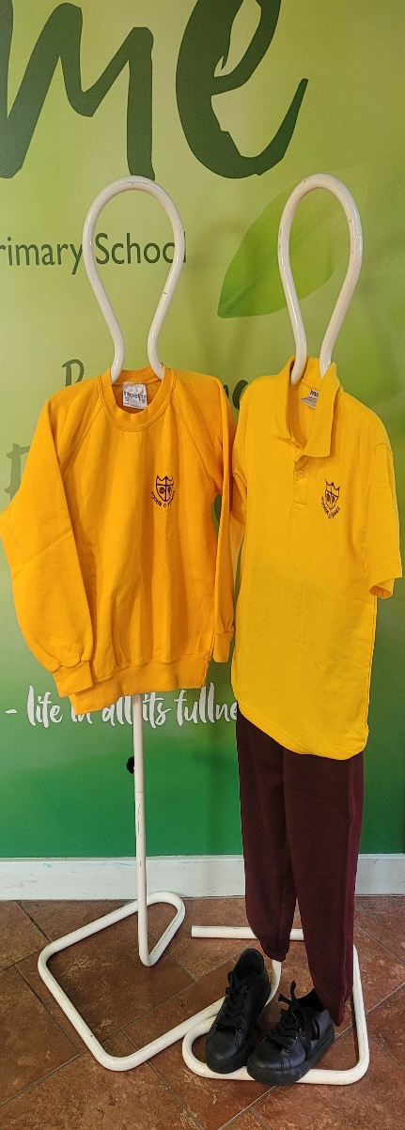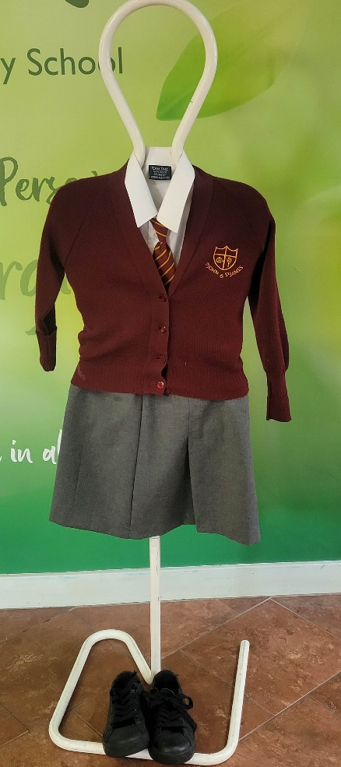

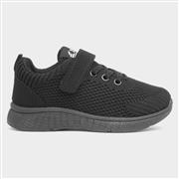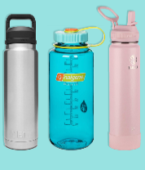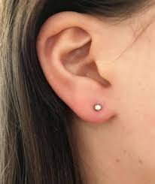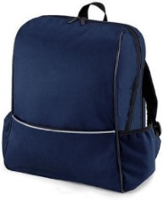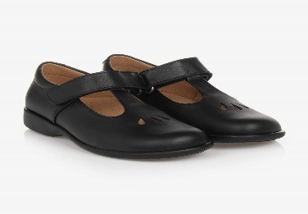

**Black Shoes Any rucksack Stud earrings Water bottle Black trainers**

**DIVINE SOLUTIONS SCHOOLWEAR ACTIVEWEAR GROUP (ONLINE**

**3 NORTHUMBERLAND PARK AMAZON (ONLINE)**

**TOTTENHAM ANY SUPERMARKET (SKIRTS, TROUSERS**

**LONDON N17 0TA & SHIRTS)**

**For ‘logo’ jumpers/cardigans**

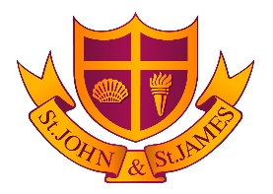

**BOYS UNIFORM**

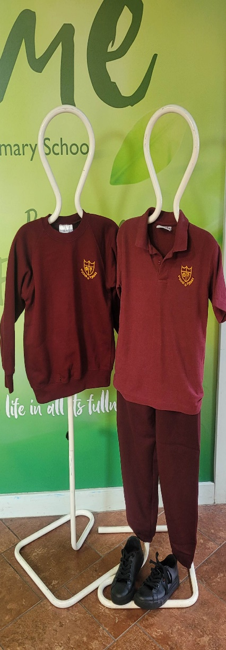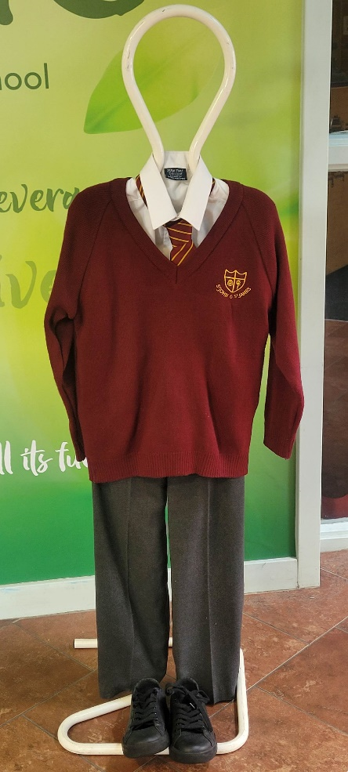

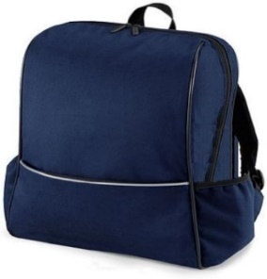

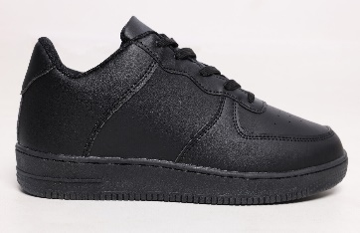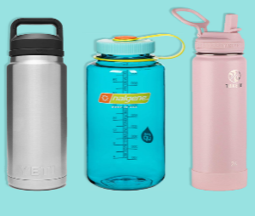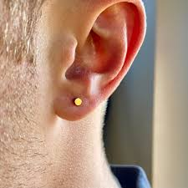

**Any rucksack Water bottle Stud earring Black trainers**

**DIVINE SOLUTIONS SCHOOLWEAR ACTIVEWEAR GROUP (ONLINE**

**3 NORTHUMBERLAND PARK AMAZON (ONLINE)**

**TOTTENHAM ANY SUPERMARKET (SKIRTS, TROUSERS**

**LONDON N17 0TA & SHIRTS)**

**For ‘logo’ jumpers/cardigan**